**OUTPUT SCREENSHOTS**

**HOME PAGE:**

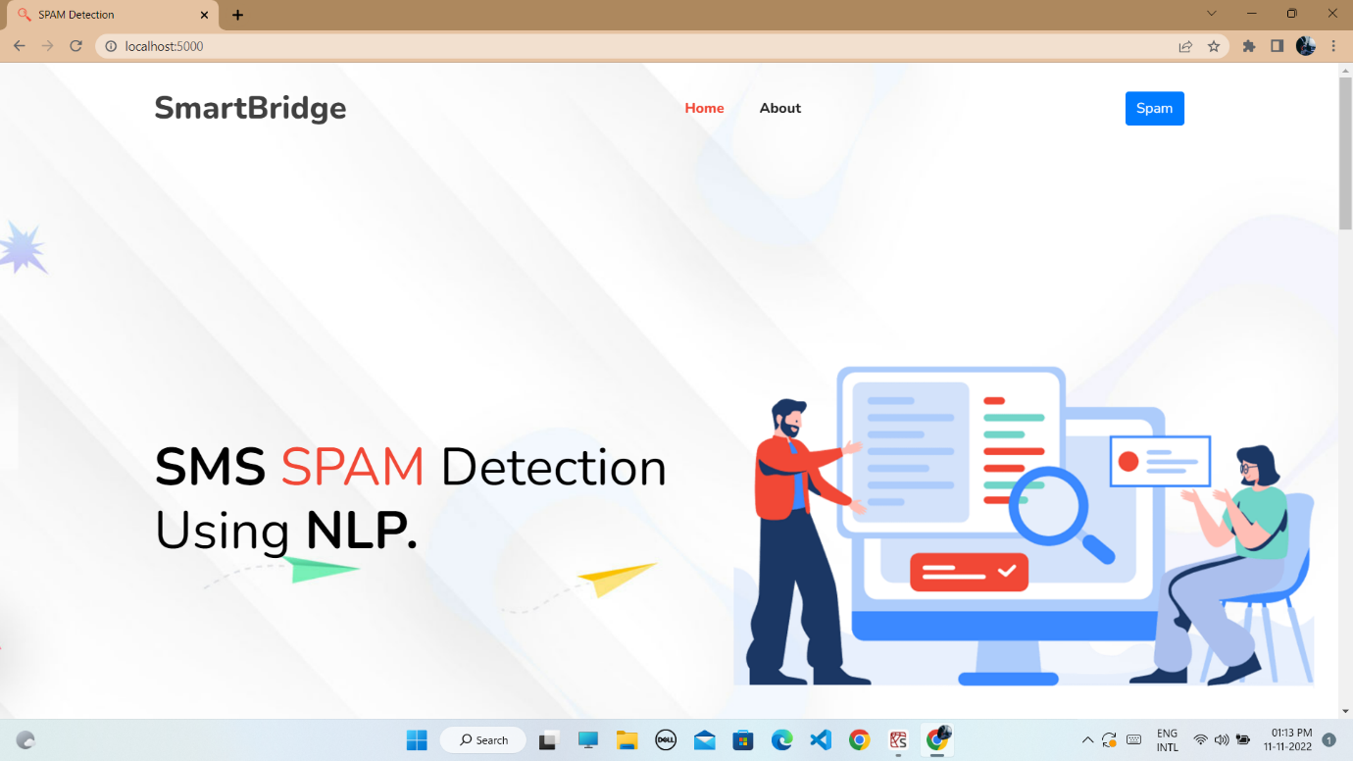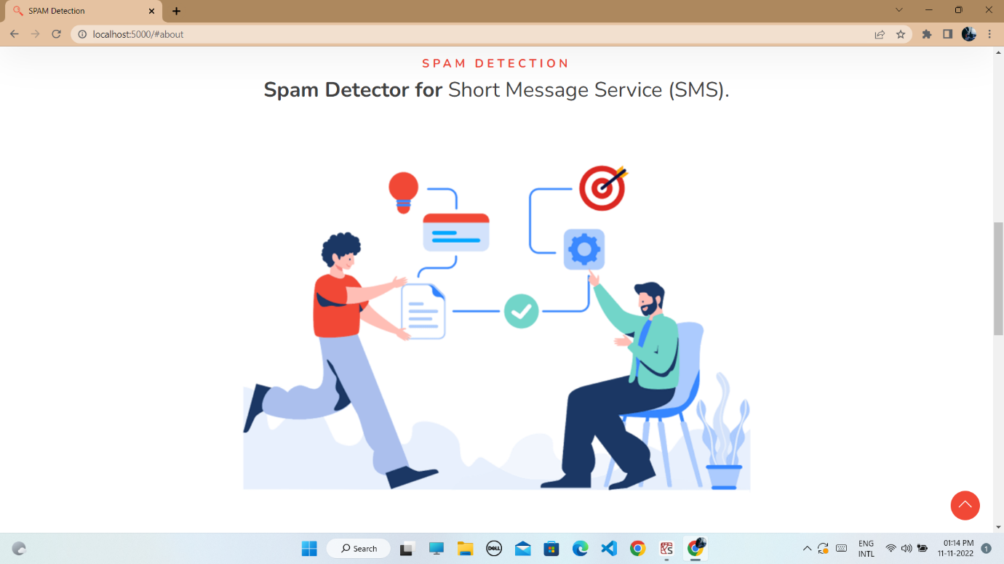

**ABOUT PAGE:**

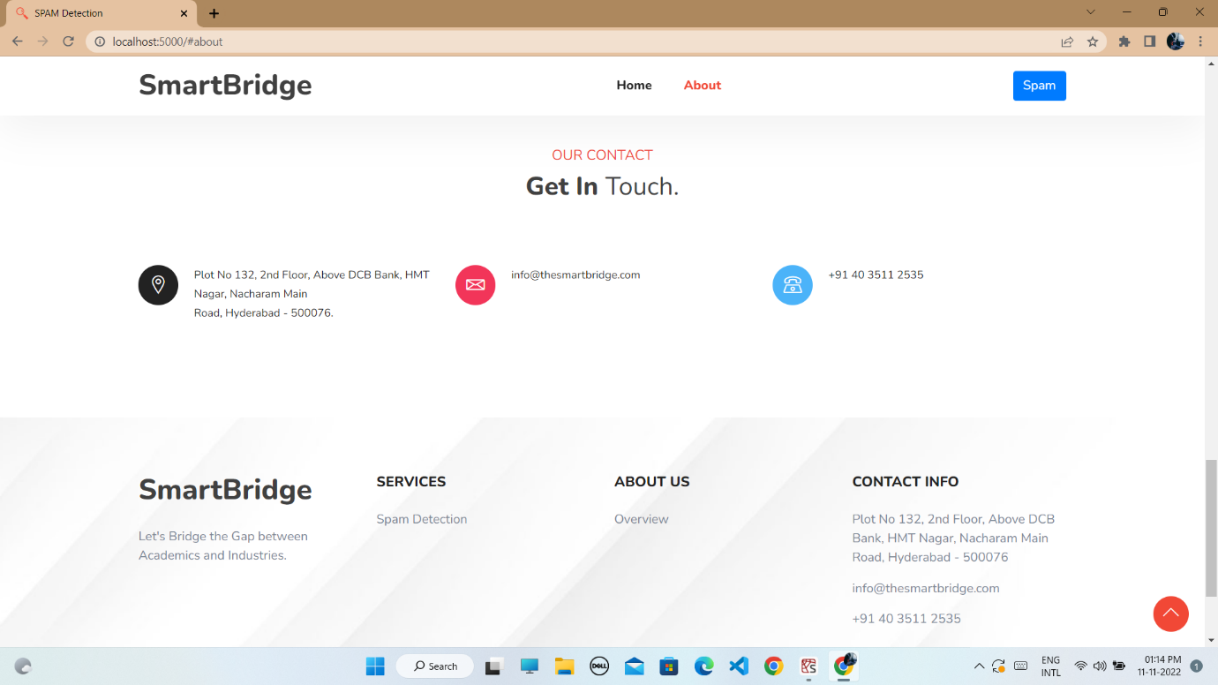

**SMS SPAM DETECTION PAGE:**

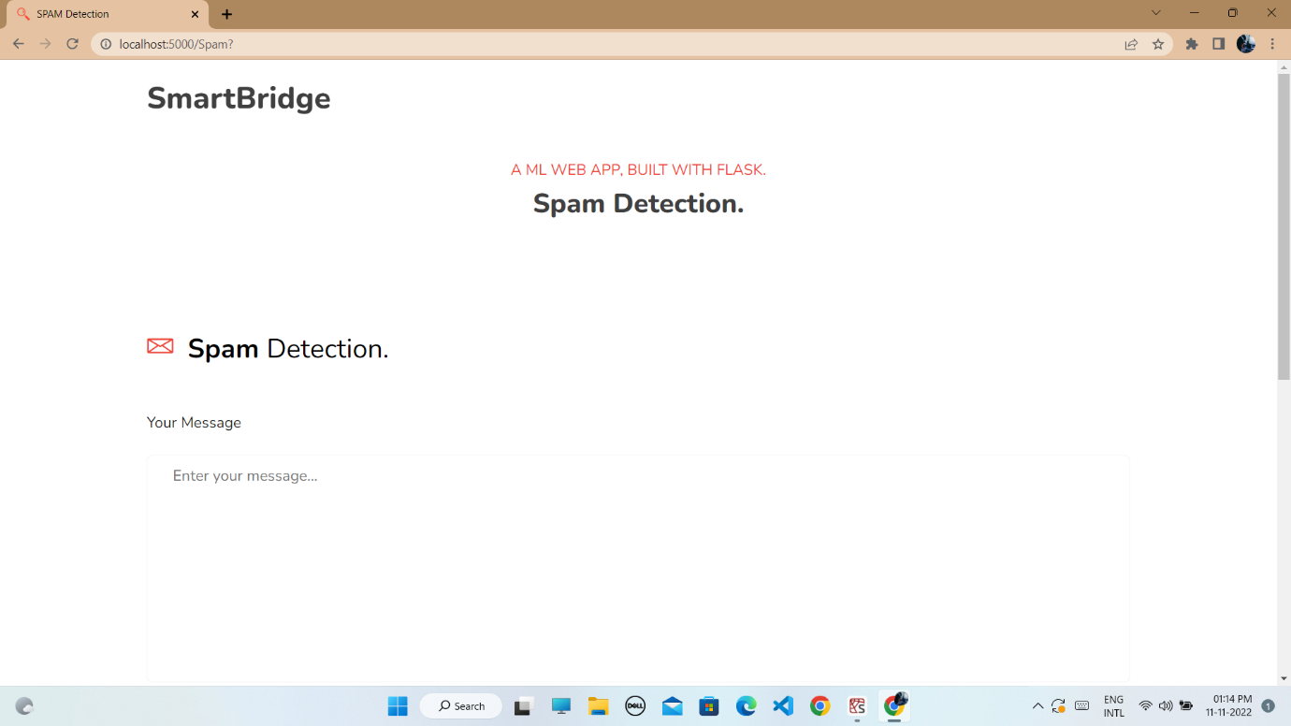

**ENTERING A SPAM SMS TO CHECK FOR SOLUTION:**

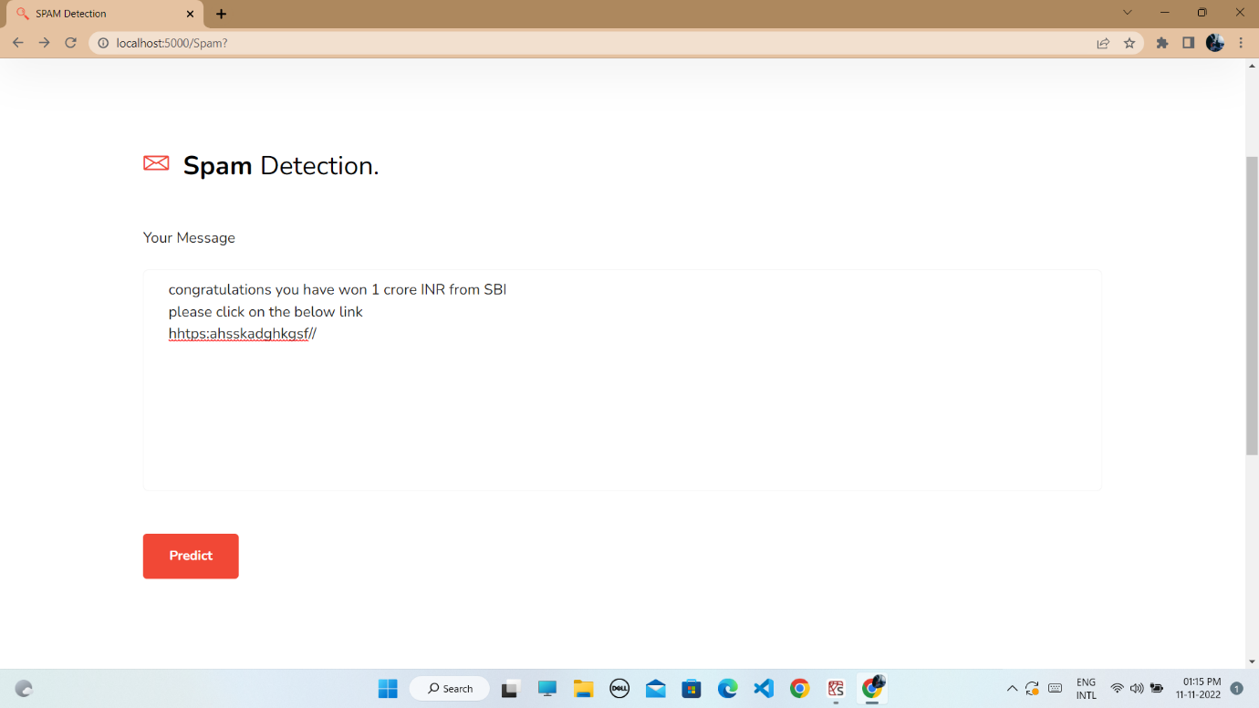

**RESULT:**

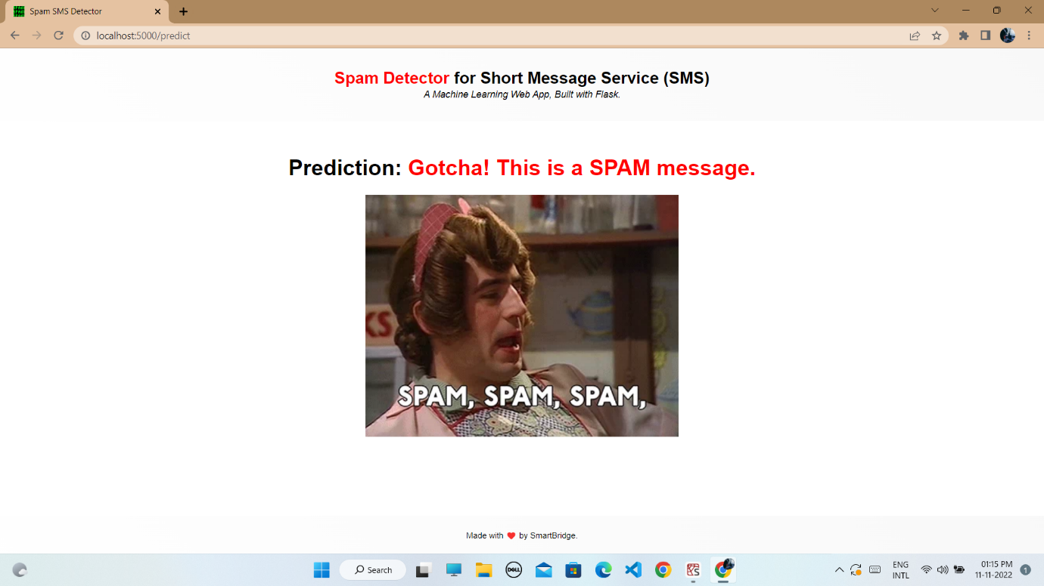

**ENTERING A NORMAL SMS TO CHECK FOR SOLUTION:**

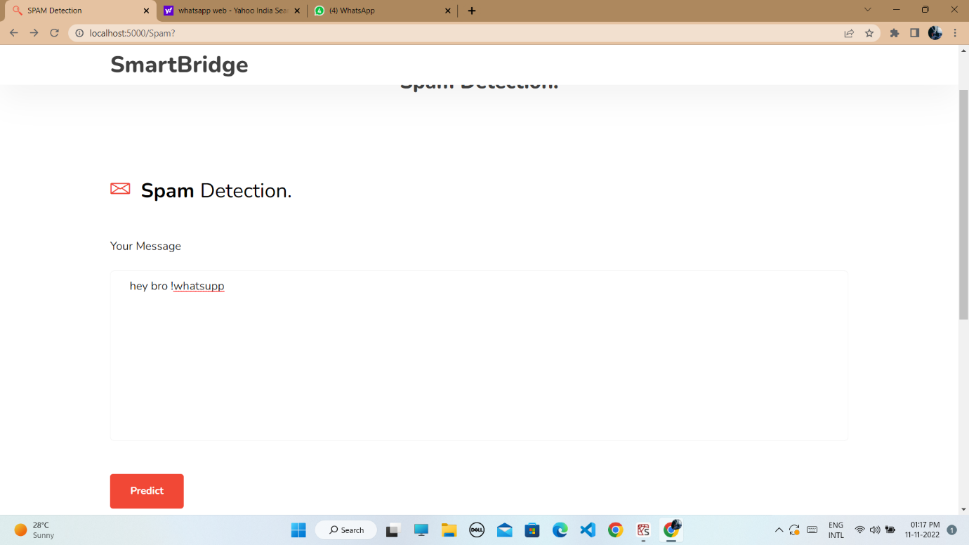

**RESULT:**

